Notarization

Wills do not have to be notarized to be valid. However, in most states you may want your witnesses to sign a short document called a self-proving affidavit before a notary public. Doing so makes the probate process easier because your witnesses won't have to come to court after your death to swear that the will is valid.

Then What?

A will doesn't need to be filed with any court or government agency. It does, however, need to be kept somewhere safe, where your executor can find it easily.

If You Move

Generally, a will is valid in any state where you die, provided it was valid under the laws of the state (or country) where you were "domiciled" when the will was made. Your domicile is the state where you have your principal home. You can have only one domicile. If you move to another state after signing your will, you should review your will in light of the new state's laws, especially property ownership laws that apply to married couples. Fortunately, they will probably determine that your original will remains valid.

Hours of Operation

Legal Assistance
(Attorney consults by appointment only)
By Appointment Only

Will Appointments
Please complete Will Worksheet BEFORE you make a will appointment!
By Appointment Only

Powers of Attorney/Notaries
Mon-Thur 0900-1600
Fri 0900-1400
Closed every second Friday

You may obtain more information at https://aflegalassistance.law.af.mil

51 FW/JA
OPC 3 BOX 2067
APO AP 96266-2067
Building 938, Osan AB
DSN 784-4131 or commercial 0505-784-4131

CREATING A VALID WILL

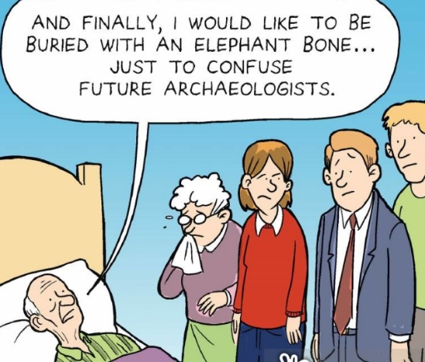

51st Fighter Wing

LEGAL OFFICE

Current as of August 2025
CREATING A
VALID WILL

The legal requirements for drafting a valid will aren't nearly as complicated as many people fear. There are just a few simple rules.

Age

To make a will, the testator (will maker) must be either: at least 18 years of age unless from one of the few states that permits younger persons to make a will if they're married; in the military; or otherwise considered "emancipated."

Mental State

The testator must be of "sound mind" to make a will. This is not a particularly high standard. Normally it means that he or she:

a. knows what a will is and that he or she is making one;
b. understands the relationship between himself or herself and those persons for whom he or she would normally provide, such as a spouse or children;
c. understands what he or she owns; and,
d. is able to decide how to distribute his or her property.

In reality, a testator must have a significantly diminished mental capacity before a court will rule that he or she lacked the mental state to make a valid will. It's also important to remember that in most cases, there's no need to prove mental state to a court. It's presumed that the testator was of sound mind, and the issue will never arise unless someone challenges it in a court proceeding.
A will can be declared invalid if a court determines that it was procured by "fraud," “duress,” or "undue influence." This usually involves manipulation of a vulnerable testator by a third person who has a stake in the will. Will contests based on these grounds are quite rare.

If you suspect someone might challenge your will on the basis of your mental competence, fraud, duress, or undue influence, be sure to see a lawyer. For example, if you plan to leave the bulk of your property to someone your family dislikes, work with a lawyer to minimize the possibility of a lawsuit.

How the Will Should Appear

You won't be around to vouch for your will's validity when it takes effect, so your state has laws designed to make sure that nobody can pass off a phony document as your will after your death.
Most states' rules (all but Louisiana's) are very similar, and they are simpler than many people imagine.

The will must be typewritten or computer-printed. Handwritten wills are valid in some states, but aren't recommended. The document must expressly state that it's your last will and testament. The will must have at least one substantive provision. Usually this is a clause that leaves some or all of your property to someone. A will that only appoints a personal guardian for your minor children and doesn't dispose of any property is also perfectly valid.

You should appoint an executor. This person (called a "personal representative" in some states) is responsible for supervising the distribution of your property after your death and seeing that your debts and taxes are paid. In most states, the probate court will appoint an executor if you fail to name one.

Witnesses

Normally, you must date and sign the will in the presence of at least two witnesses. Three are required in Vermont. In many states, the witnesses cannot be named to receive property in your will. The witnesses watch you sign your will, and then sign it themselves.

